Protocol single-gene 5’PSeq

I. Yeast culture
Yeast cultured in two flasks (in 15ml YPD each) at 37Cº until OD of ~2 is reached. 5 ml taken from each flask to serve as negative control, and the remaining cultures incubated at 2mM H2O2 for 5 and 30 min @ 37Cº. 5ml from each culture were collected after incubation period.
All samples were pelleted by centrifugation and frozen at -80Cº for a week.

II. RNA extraction
(Invitrogen RiboPure Yeast kit?)
Yield measured with nanodrop:
S1-5min: 625ng/ul
S2-30min: 602ng/ul
S3-control: 644ng/ul
S4-control: 631ng/ul

III. Library preparation
SSRNA ligation (Following modified High-throughput 5’PSeq protocol)

1ul 10X T¤ RNA ligase buffer
1ul rP5_RND oligo 100uM
1ul ATP 10nM
0.2ul RNAsin+
0.3ul T4 RNA ligase 1
4ul PEG 50%
2.5ul Yeast RNA (~600ng/ul)

Incubated at 25Cº for 2H
Washed with 1.8X Vol. RNAclean XP beads
Eluted in 15ul RNAse-free water

IV. Reverse transcription (Following SuperScript II protocol with custom oligo):
0.9ul RT custom oligo mix(0.3ul each totaling 2pmol DNA)
It is recommended to use 2pmol custom oligo per RT reaction. We use 2pmol of each of the 3 custom oligos (6pmol oligo per sample)
11.8ul Yeast RNA

Extracted with 1.8X Vol. RNAclean XP beads (Not enough Ampure XP beads for all samples, only MagSi beads left and nobody around to ask)

V. Library PCR amplification:
5ul Yeast RT DNA
0.4 mpx adapter:
S1-5min MPX 9
S2-30min MPX 10
S3-control MPX 11
S4-control MPX 12
20ul Phusion HF MM
0.4 NEBi 501
14.2ul MilliQ water

PCR progam:
1x 30s @ 98Cº
18x 20s @ 98Cº, 30s @ 65Cº, 30s @ 72Cº
1x 7min @72Cº
Hold @ 4Cº

Purified with 2X Vol RNAclean XP beads and eluted in 5ul MilliQ water

Qubit concentration, :
S1-5min 25ng/ul
S2-5min 30ng/ul
S3-5min 35ng/ul
S4-5min 35ng/ul

Bioanalyzer:
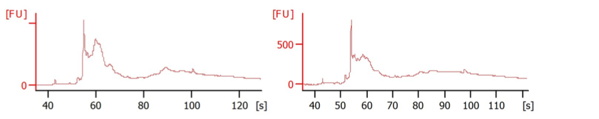
S1 S2

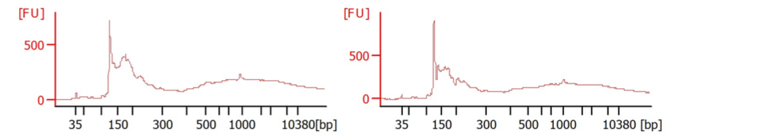
S3 S4

